The Mediterranean Dialogue was established in 1994 to coordinate with Israel and countries in North Africa.
Partnership for Peace |  |  | Mediterranean  Dialogue | Map of NATO Partnerships
Commonwealth of  Independent States | Other Cold War  socialist economies | Militarily neutral Cold  War capitalist economies
Armenia | As part of Yugoslavia | Austria | Algeria | 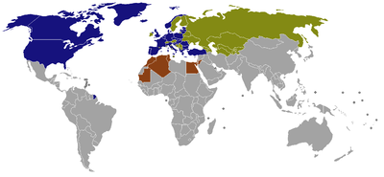
Azerbaijan | Bosnia and Herzegovina | Finland | Egypt
Belarus | Macedonia | Ireland | Israel
Kazakhstan | Montenegro | Malta | Jordan
Kyrgyzstan | Serbia | Sweden | Mauritania
Moldova | As part of the Soviet Union | Switzerland | Morocco
Russia | Georgia |  | Tunisia
Tajikistan | Turkmenistan |  |  | NATO member states | Partnership for Peace countries
Uzbekistan | Ukraine |  |  | Mediterranean Dialogue countries
- Other third countries also have been contacted for participation in some activities of the PfP framework: Afghanistan^{[48]}.

